Valeria Anel Duque Salgado NAO ID: 3306 08/09/2025

GitHub and Digital Repository Management
FINAL PROJECT
IN-MEXICO PROGRAM BACKEND
DEVELOPER CERTIFICATION

Contents:
Creation of branch "A" from "Main" 2
1. Creation of docs.txt in branch "A": 2
2. PR created for branch "A": 4
Creation of branch "B" from "Main" 5
3. Creation of a different docs.txt in branch "B" 5
4. PR created for branch "B" 7
Conflict resolution process 8
Git command used to revert changes 9
Approved PRs and merged branches 10
Notes for feedback: 11

R E P O S I TO R Y C R E AT I O N I N G I T H U B A N D P R O J E C T U P LO A D :

REPOSITORY CREATION:

Inside the GitHub account, we must go to https://github.com/new . So, we can customize our repository:
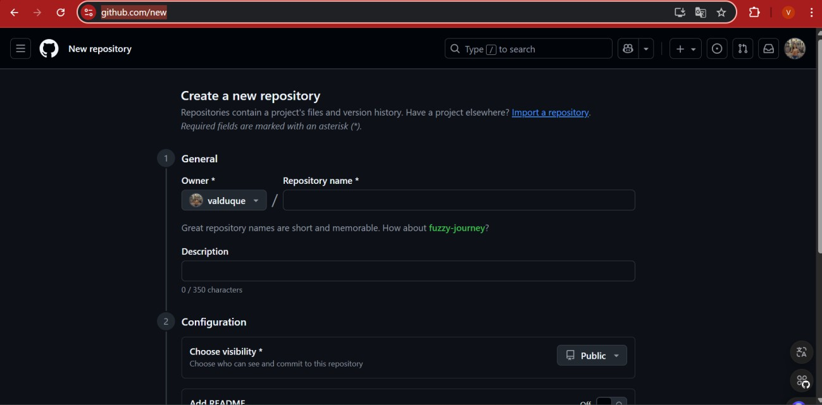

After that, just click the “Create repository” button:


And now you can see your repository’s page:
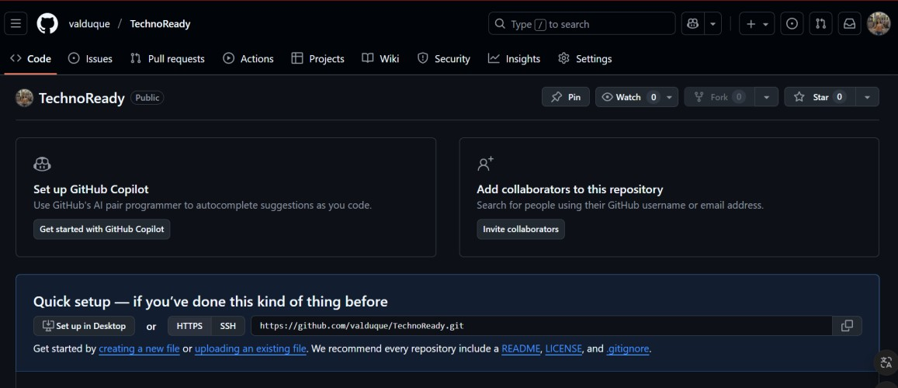

Also, it’ll appear on your repositories’ list:


REPOSITORY CONNECTION WITH LOCAL REPOSITORY:

From the local repository, GitBash must be open and initialize with the “git init”

command:

Then add the command “git init add origin” followed by the URL of you github

repository:

PROJECT UPLOAD:

Inside our repository, and once our git is initiated, git execute de git add command, this will send all our files to the staging area:

The, we create a commit with the git commit -m “message” and press enter:
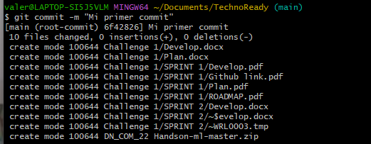

The just write the command git push origin branch.name:
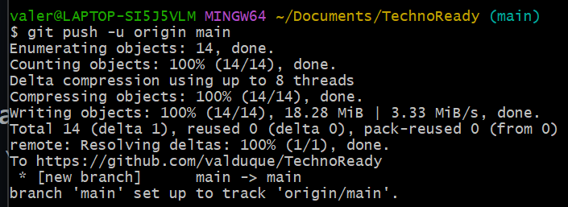

And now the project appears inside the repository on GitHub:
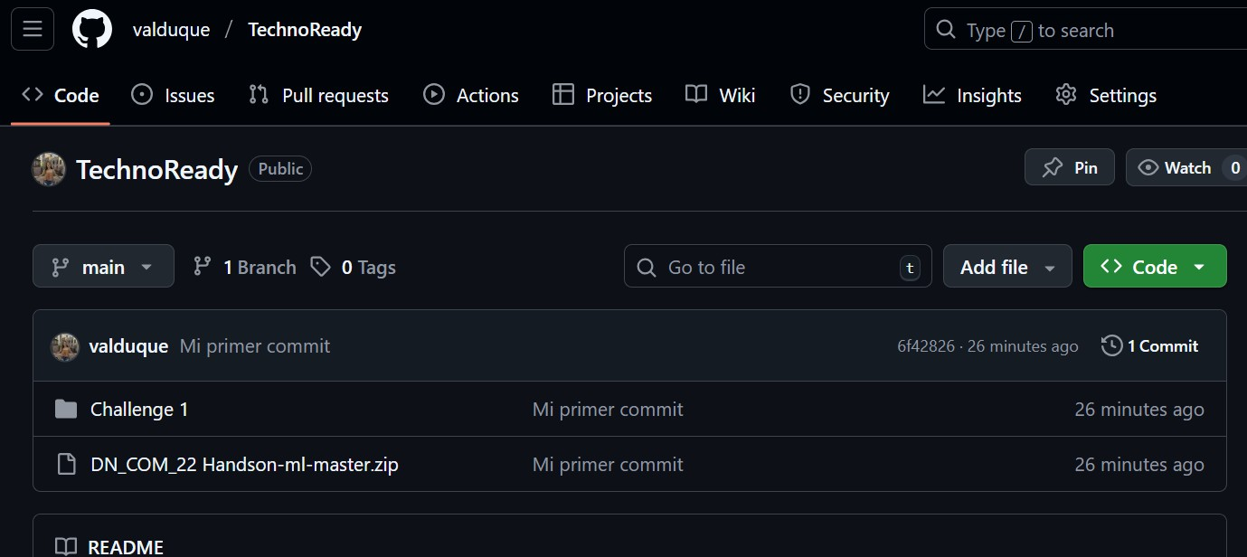

N E W B R A N C H C R E AT I O N :

Inside your project, write the command git branch name.brach:

To confirm the branch creation, just write the command git branch:
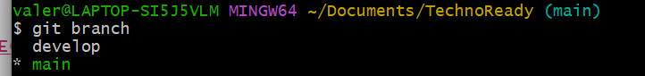

UPDATE TO THE REQUIREMENTS.TXT FILE:

If there is ever a desire to update something, there are some rules that must be followed. First, make the desired changes in your file:
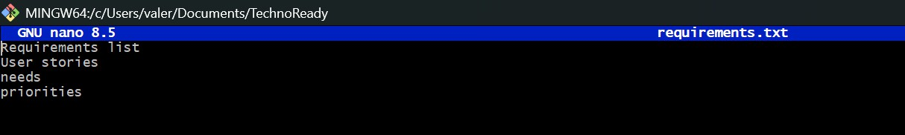

Then, save the changes with the combinations in the console below:
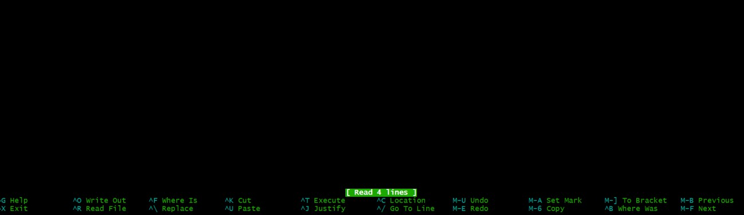

Once the changes have been done, you can upload them with a push to the desired branch.

C R E AT E D P R :
If there is content uploaded that must be reviewed by other collaborators, it’s possible to create a PR to make the whole team to be on the same page or at least, on the same code.
To do this, it must be already committed and pushed to the branch. Once it’s done, in the project’s menu should appear an option to create a pull request, it shall be clicked on the “create pull request” button:
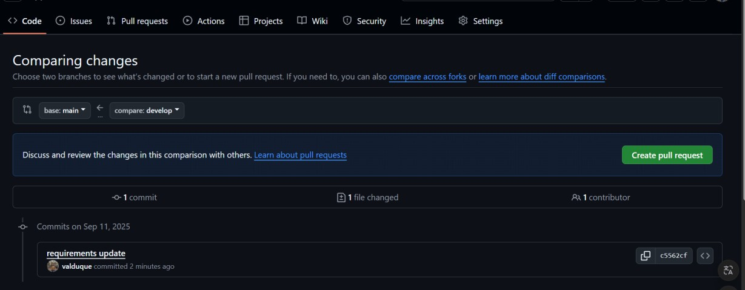

It will be able to show the changes:
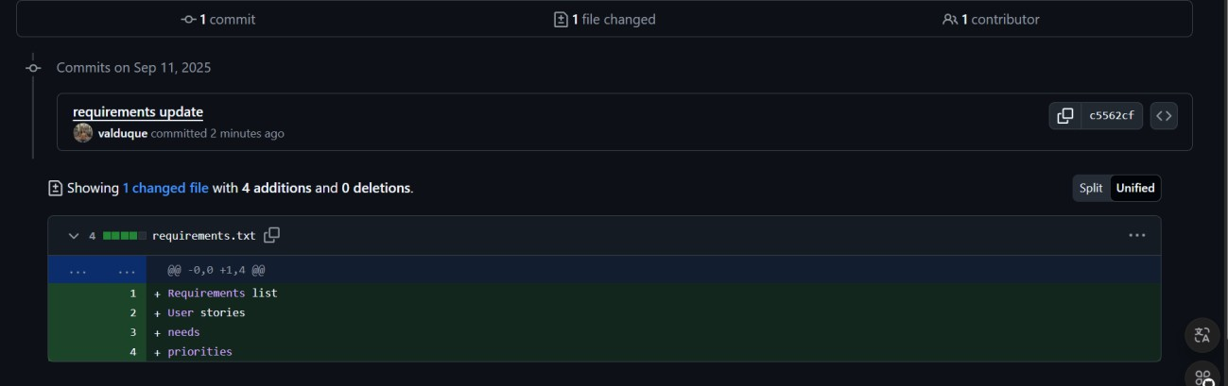

And now, it’s possible to compare and do the pull request:
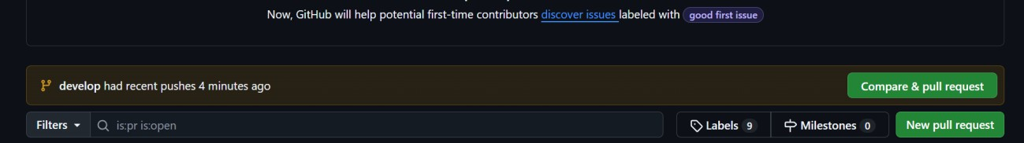

It can be added descriptions and comments:
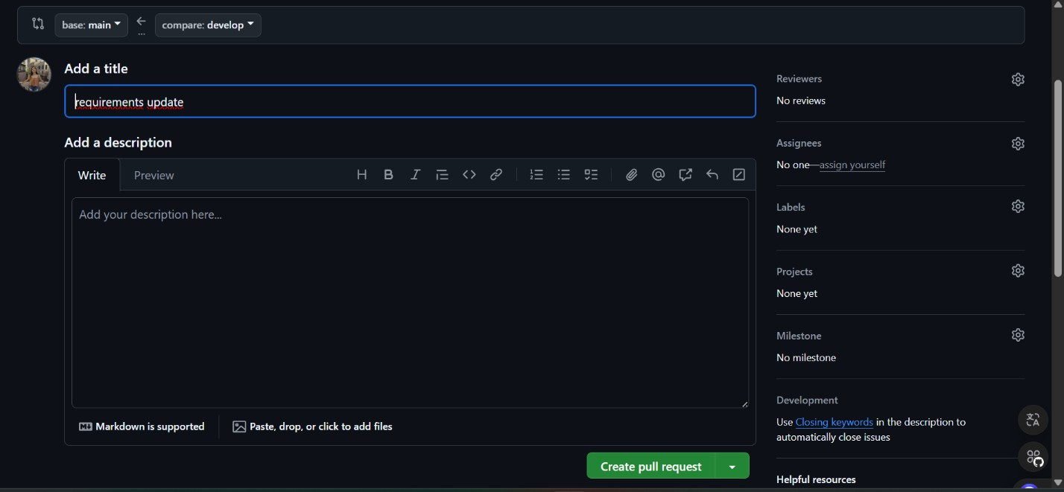

PR APPROVAL IN GITHUB:

If a pull request is done on the project, a collaborator can approve another collaborator’s work to be added to the project. The GitHub system will show if there is any conflict with the branch, or if it’s not possible to merge with the new work. In this case, it’s possible:
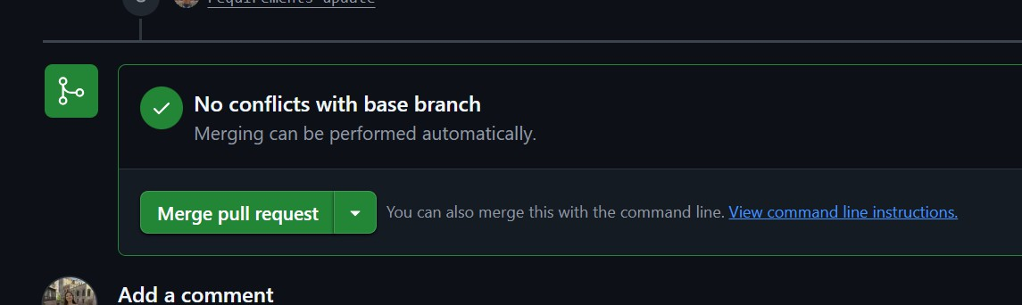

It must be clicked the “merge pull request” button and add any commentary if needed:
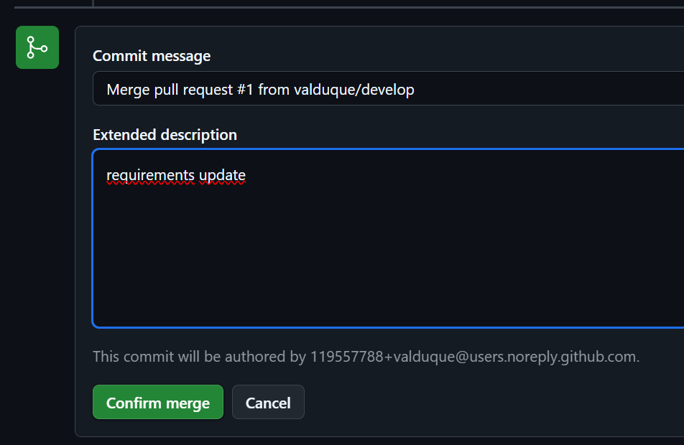

Lastly, the system will confirm that the action is finished successfully:
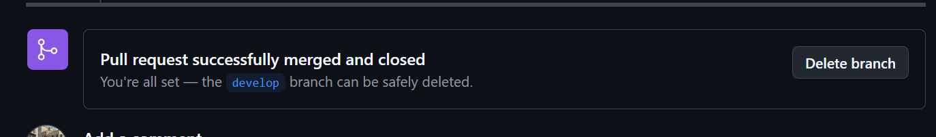

Creation of branch "A" from "Main"

From branch Main we just must write the command “git branch name.branch” in this case the branch will be called “A”:
Then, switch to the new branch with the command “git checkout branch.name”:

Creation of docs.txt in branch "A":
Inside the desired branch, write down the command “touch name_file.txt”:

Add a few lines with the command “nano name_file.txt”:
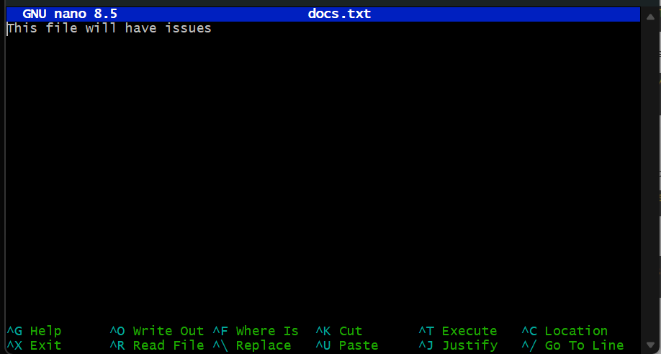
Add, commit and push all the changes with the command “git push -u origin A”:
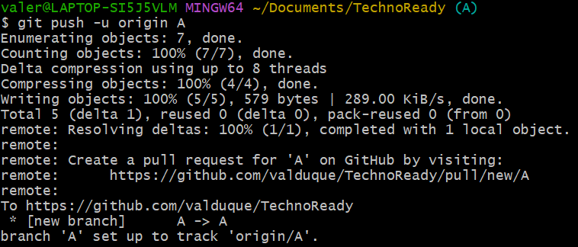

PR created for branch "A":
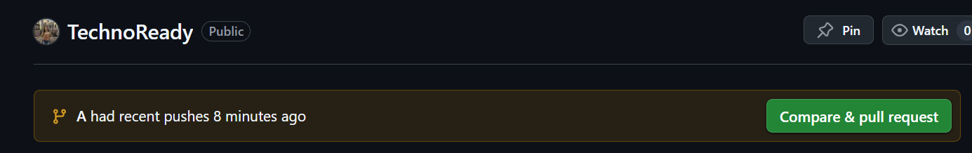
On the project’s Github repository page, it will show the new branch and pushes created by it. “Comapre and pull request” will be clicked:
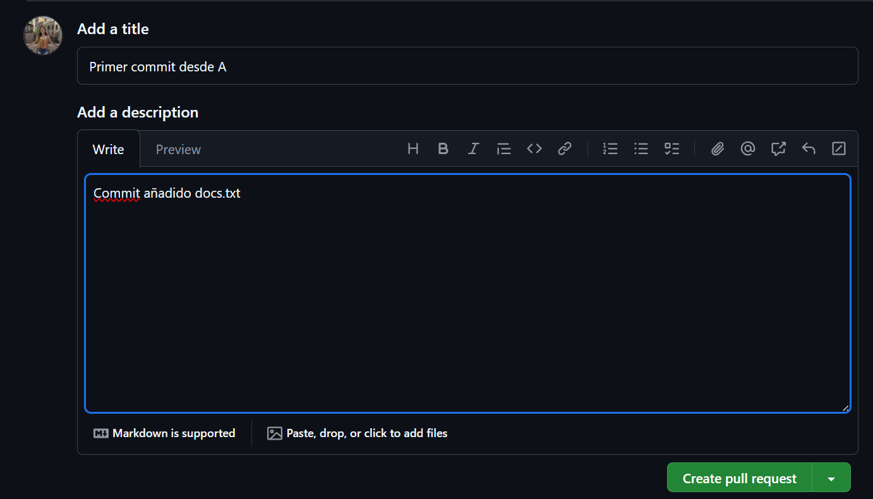
Then, the customizable page for the pull request will appear:

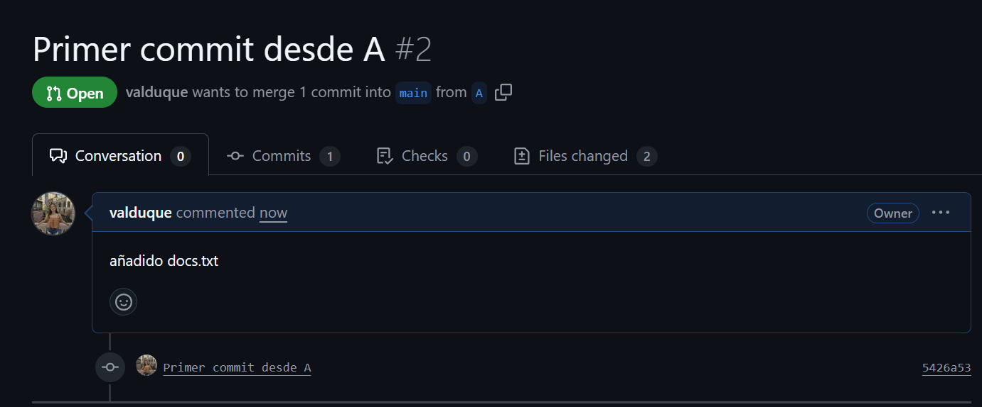
Once finished all the details, just press “create pull request”:

Creation of branch "B" from "Main":

From branch Main we just must write the command “git branch name.branch” in this case the branch will be called “B”:

Then, switch to the new branch with the command “git checkout branch.name”:

Creation of a different docs.txt in branch "B":
Inside the desired branch, write down the command “touch name_file.txt”:
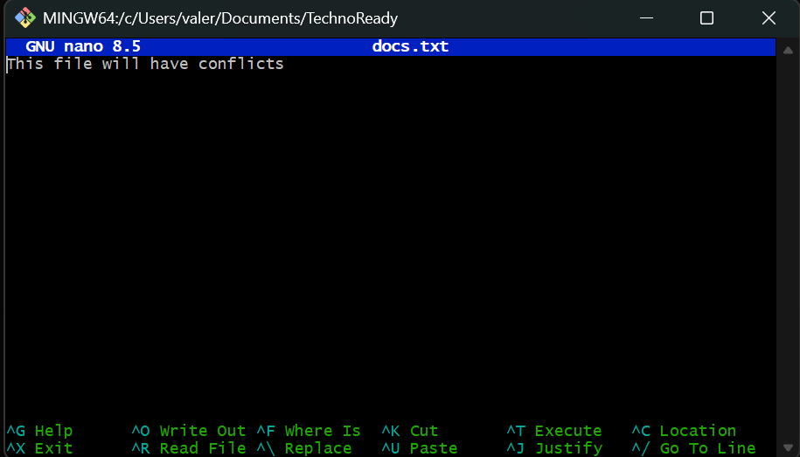
Add a few lines with the command “nano name_file.txt”:

Add, commit and push all the changes with the command “git push -u origin A”:
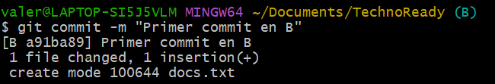
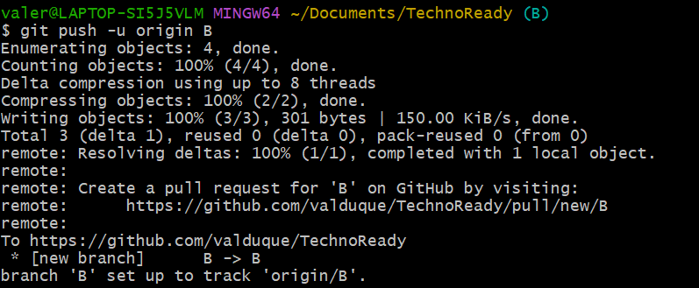

PR created for branch "B":
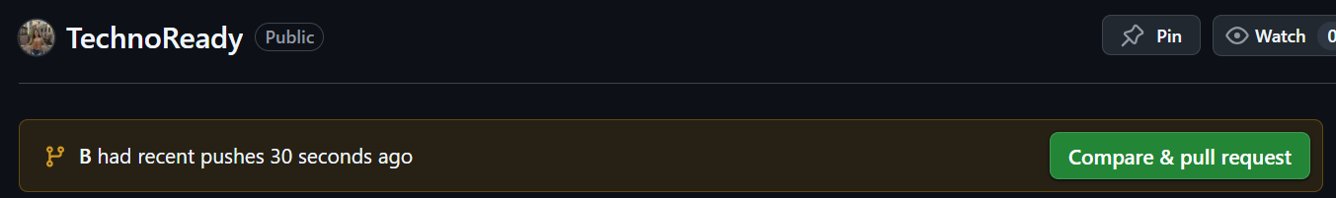
On the project’s Github repository page, it will show the new branch and pushes created by it. “Comapre and pull request” will be clicked:

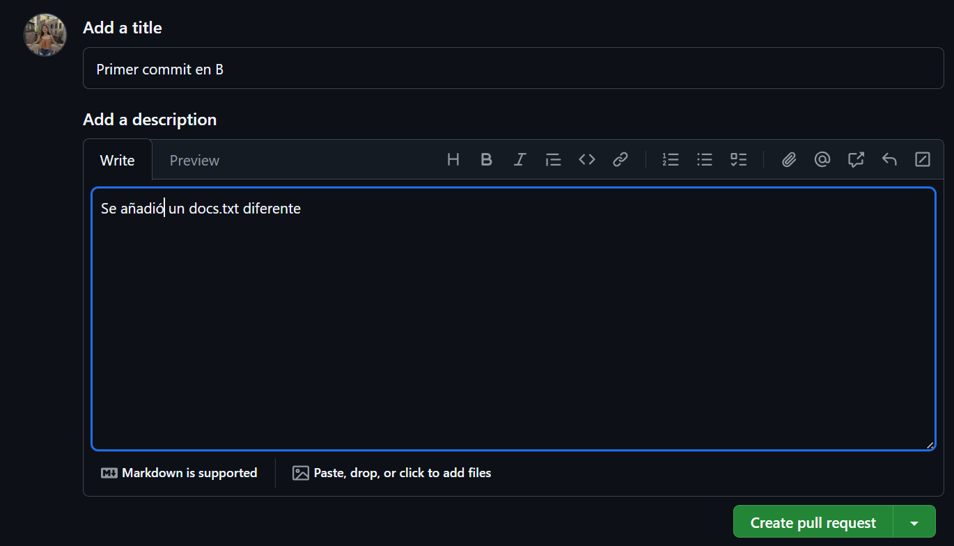
Then, the customizable page for the pull request will appear:

Once finished all the details, just press “create pull request”:
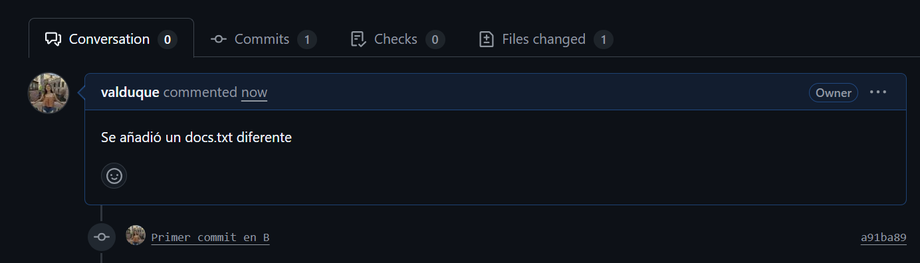

Conflict between branches:

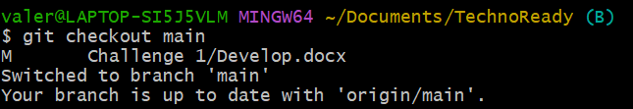
When we want to merge both branches, the creation of docs.txt, will bring up problems. First, let’s go to the main branch:

In main branch, let’s merge with the A branch with main branch:
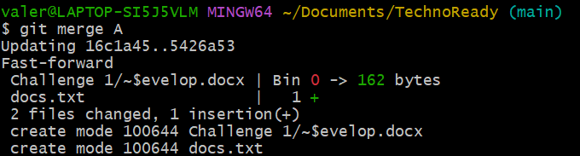

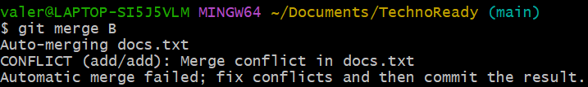
Then, merge the B branch with the main, to get the conflict:

When this message It’s showed, that means we are having a conflict between branches:


Conflict resolution process:

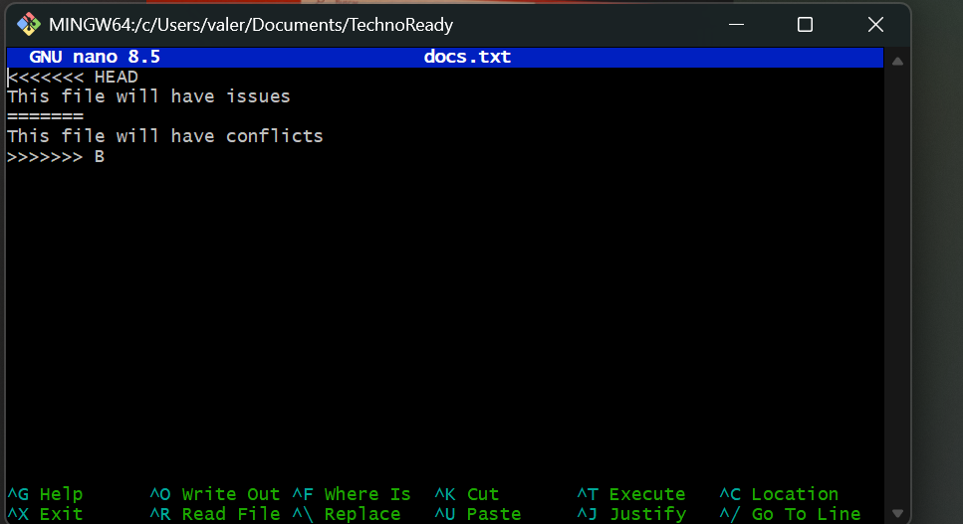
We face a challenge with the docs.txt, since now it has conflict;

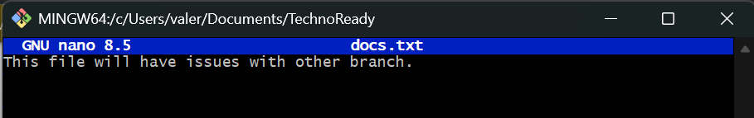
For this exercise, it was chosen to make the changes manually.

Git command used to revert changes:
Once the changes are made. We finish the merge:
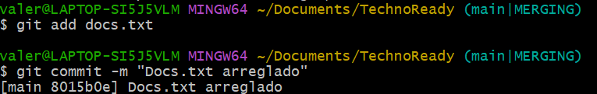

Approved PRs and merged branches:

Now, we can approve the pull request for both branches, in GitHub:
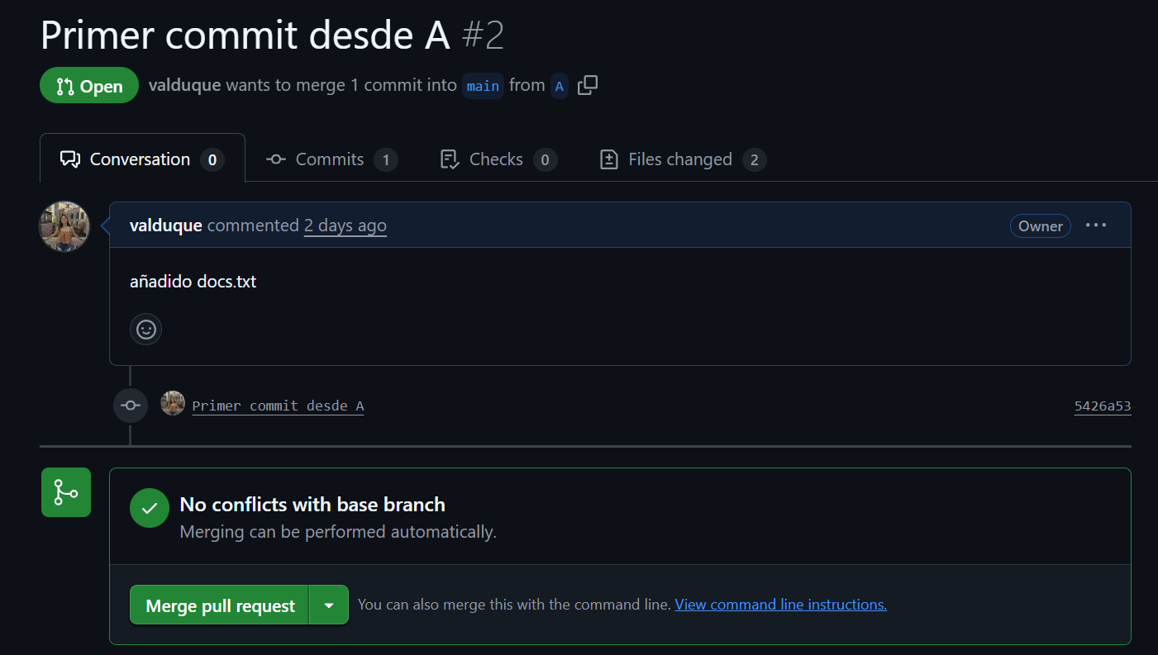

And everything is correct and working fine:
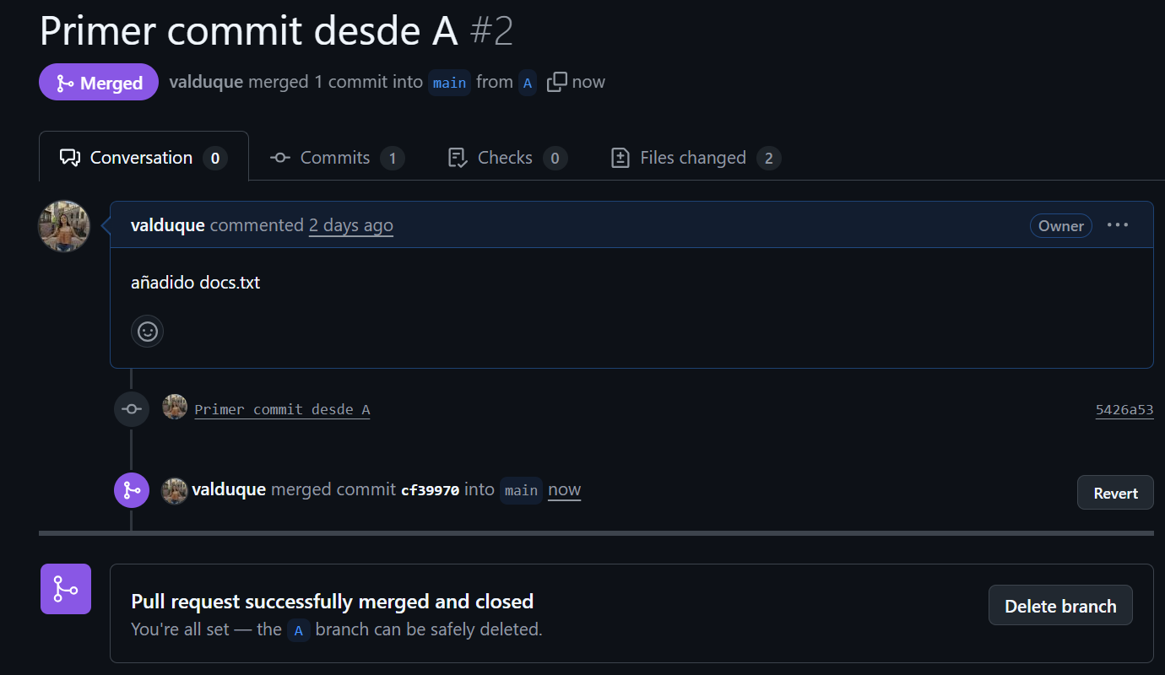

Pull request the other branch:
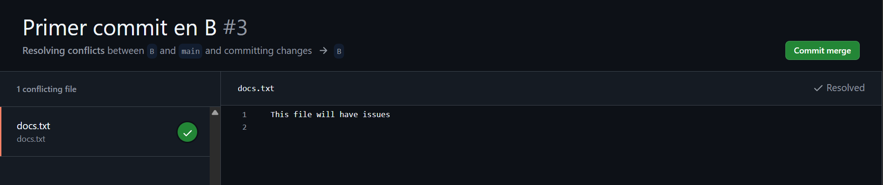
The other branch may or may not require you to fix the conflicted file. If you have to solve it just do it manually again on GitHub:


Then commit the merge:

And if there is not any issue, merge again:
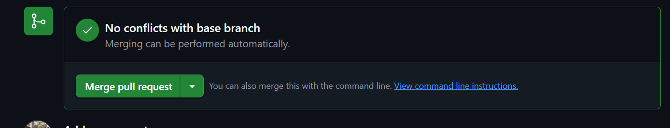

Notes for feedback:

If there is only a branch in the local project, the first time it must be pushed with “git push -u origin name.branch”:

origin → your remote on GitHub.

A → the name of your local branch.

-u → links your local branch to the remote, so later you will only need to do git push.
There are plenty ways to resolve a conflict, it’s easier to develop communication between collaborators in order to know which version must be followed.
It’s not necessary the command “revert” if you already did manually changes.

